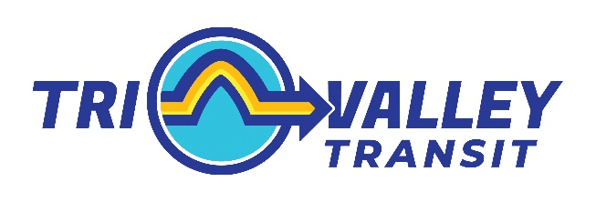

UPDATE

To: Senate Transportation Committee
From: Jim Moulton, Executive Director
Date: January 9, 2026
Re: Update re Washington County Transition

Dear Members of the Committee,

Below is a summary of key information regarding the transition of Washington County services.

- Target transition date remains July 1, 2026.

- Held multiple meetings between GMT and TVT leadership and other management staff; Staff from both agencies visited facilities at each other’s locations.

- Added GMT Board Member to TVT Transition Committee.

- Worked with GMT to:
  - Establish MOU with Sugarbush for services and local match.
  - Leverage aging GMT grant to hire Volunteer Coordinator.
  - Establish new Community Relations Manager role (& hire) for local match.

- Invited GMT Union participation in upcoming TVT Union negotiations; Negotiations to start this month.

- Facilities
  - Leveraged GMT grants to begin fixing critical facility flaws.
  - Began work to transition facility lease form GMT to TVT.

- I/T
  - Doing assessment of GMT systems to a) ID needs, and b) develop transition plan
  - To begin installation of new statewide Dispatching software at Washington County site.

- Learning lessons from RCT/FGI transition.

Please let me know if you have any further questions or comments. I can be reached at 802-355-2287 or jim@trivalleytransit.org. Thank you.

